|  |
| --- |
| User Manual  Samuda Commercial |
| REFERENCE: GW/ERP/USER MANUAL |
|  |
| **Genweb2 Ltd.** |
| **11-Apr-18** |



|  |
| --- |
|  |

# Document Information

|  |  |
| --- | --- |
| Document Name | User manual for Commercial |
| Document Author | Rashedul Alam |
| Document Version | 1.0 |
| Release Date | 11th t April, 2018 |

|  |  |
| --- | --- |
| Review by | Md. Matiar Rahman |
| Review Date | 12th April, 2018 |
| Approved By |  |
| Approval Date |  |

# Document History

|  |  |  |  |  |  |
| --- | --- | --- | --- | --- | --- |
| A=Added, M=Modified, D=Delete | | | | | |
| **Version No** | **Date** | **Section No** | **A/M/D** | **Description of Change** | **Author** |
| 1.0 | 11-April-2017 |  | A | Initial | Rashedul Alam |
| 1.1 | 17-April-2017 |  | A | Approved PR, Bill of Landing | Rashedul Alam |
|  |  |  |  |  |  |

Contents

A. Document Information 2

B. Document History 2

1. Introduction 4

1.1 Purpose of User manual 4

1.2 Approved PR View by Commercial user/Manager 4

2. Import LC (local) 4

2.1 import LC (local) creation by Commercial user/Manager 4

2.2 Confirm import LC (local) by Commercial user/Manager 7

2.3 Amendment creation by Commercial User/Manager 8

2.4 Create Shipment by Commercial User/Manager 9

2.5 Shipment Cancel by Commercial User/Manager 9

2.6 Create On board by Commercial User/Manager 10

2.7 Create Receive doc by Commercial user/Manager 10

2.8 Confirm Send To C&F by Commercial User/Manager 12

2.9 Confirm ETA by Commercial user/Manager 12

2.10 Confirm C&F quotation by Commercial user/Manager 13

2.11 Confirm C&F clear by Commercial Manager 14

2.12 Shipment done by Commercial Manager 16

2.13 LC Evaluation by Commercial Manager 16

2.14 LC done by Commercial Manager 17

2.15 Send RFQ Email by Commercial Manager 18

3. Reports 19

3.1 Letter of Credit reports view by Commercial Manager 19

# 1. **Introduction**

The purposes of this User manual is to clearly identify the customer requirements and provide a detailed document. The customer will read this document and get a clear view the sales module. It will also help the review team to validate whether the customer requirements have been fulfilled or not.

## Purpose of User manual

This document is the User Manual of Commercial. It is intended to provide all the necessary information to use this software to develop application software running on the workstation.

## 1.2 Approved PR View by Commercial user/Manager

Approve PR will view by Commercial user.

Commercial user can View Approve PR using the menu **Commercial ‣ Approved PR (Local)** and click

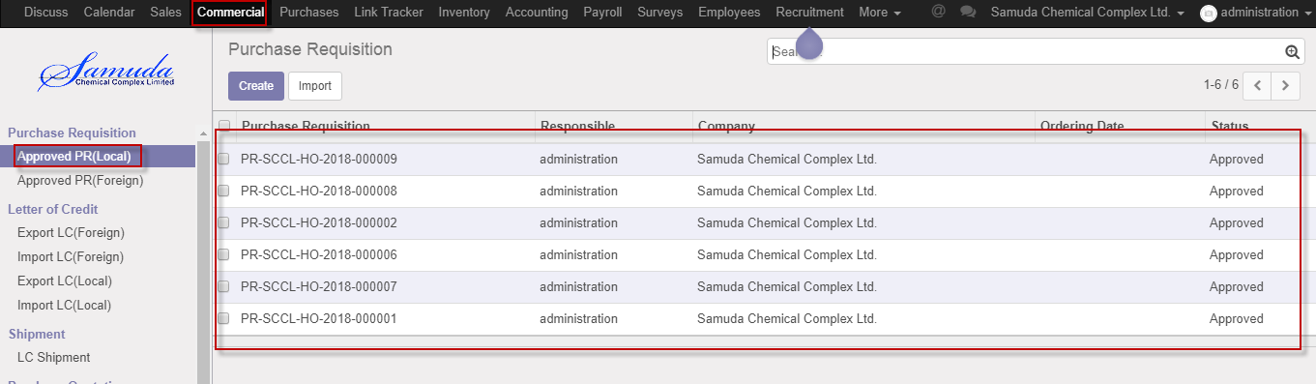

Figure: Approved PR (local) List view

# 2. Import LC (local)

Letter of credit (LC) is two type Local or foreign .Here we will show import LC local process which is similar to import LC (Foreign)

## 2.1 import LC (local) creation by Commercial user/Manager

Import LC (local) will be created/Edit by Commercial user.

Commercial user can create Import LC (local) using the menu **Commercial ‣ Letter of Credit** and click **Create.**

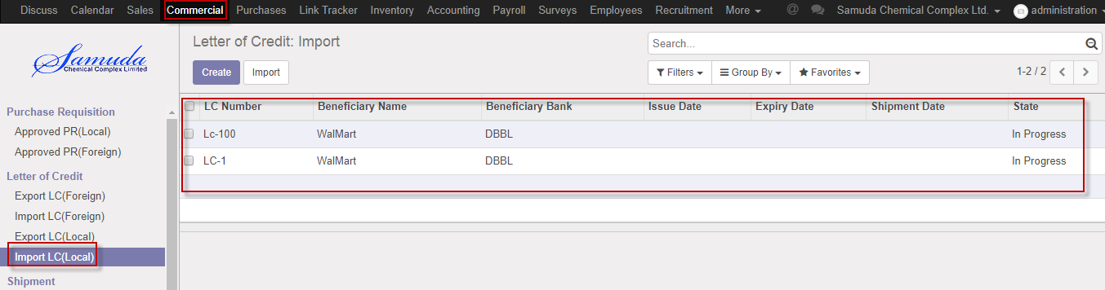

Figure: Import LC(local) List view

We need to set the following:-

**Purchase order**: Select purchase order. Multiple purchase order select will possible here and after select all product list will come in product caption

**Description:** Enter description.

**Applicant candidate:** Select applicant candidate.

**Applicant bank:** Select applicant bank.

**Beneficiary candidate:** Select beneficiary candidate.

**Beneficiary Bank:** Select beneficiary bank**.**

**Operating unit:** Operation unit should be same with purchase order operating unit.

**LC value:** Enter LC value**.**

After entering all information click **Save & Open**.

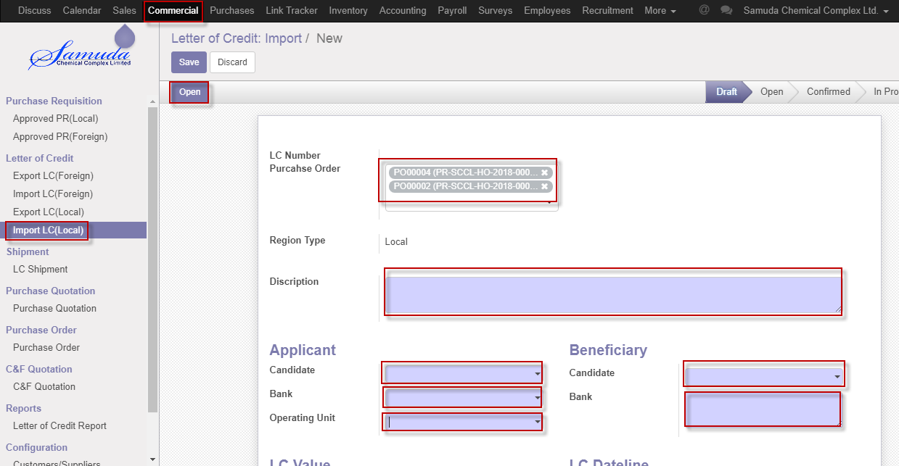

Figure: Import LC (local) creation

If any LC related document Attachment require then will be uploaded here.

**Commercial>>Import LC>>Attachment** tab

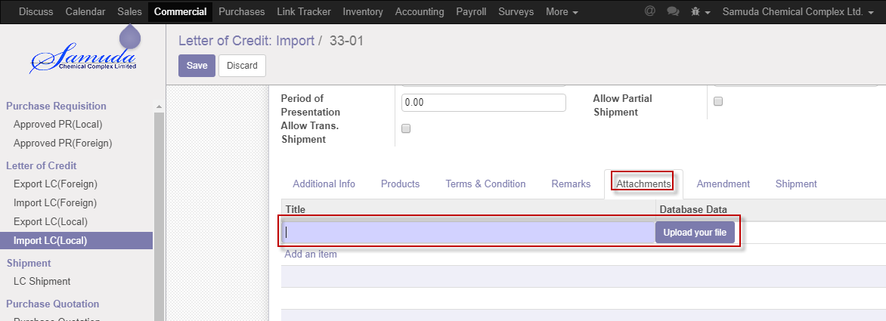

Figure: LC Document Attachment

Done shipment will show in Shipment Tab.

**Commercial>>Import LC>>Shipment**

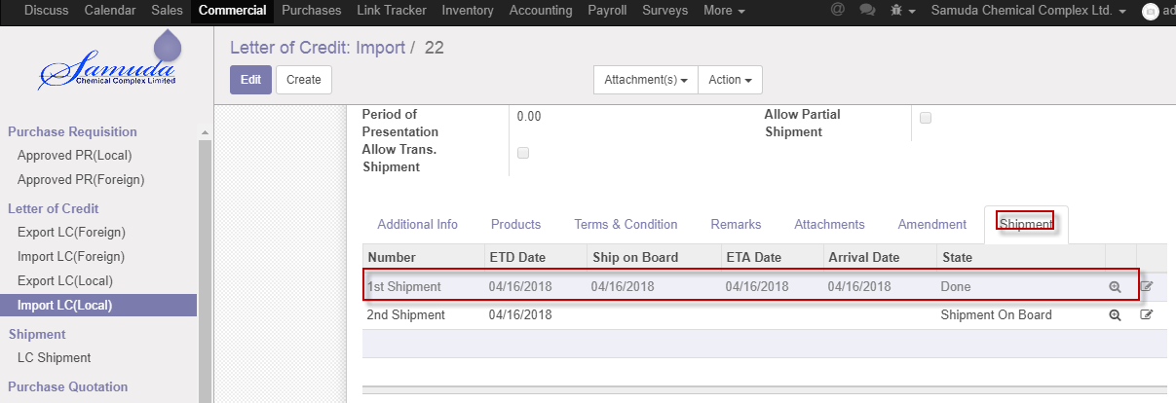

Figure: Shipment done

## 2.2 Confirm import LC (local) by Commercial user/Manager

Import LC (local) will be Confirm by Commercial user or Manager Click **Confirm** button

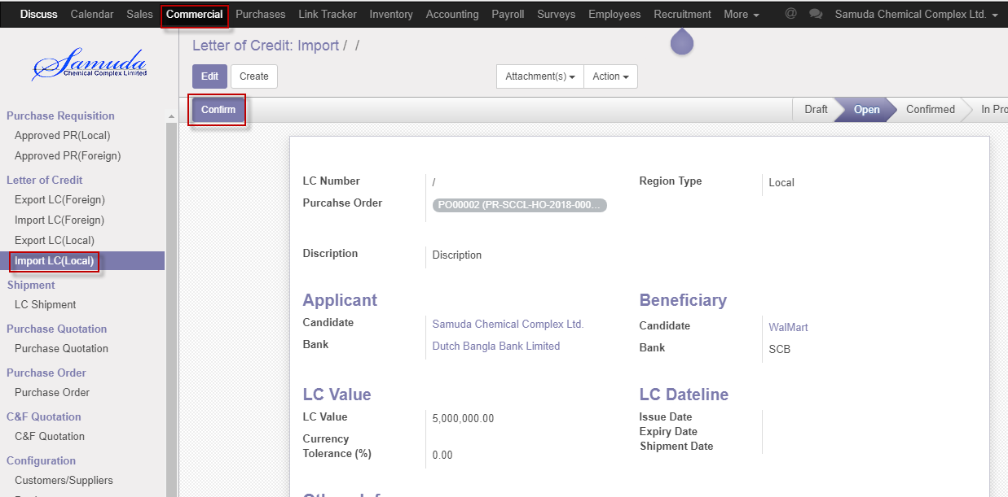

Figure: Import LC (local) Confirm

After click confirm button below window will open & will enter LC number then **Save**

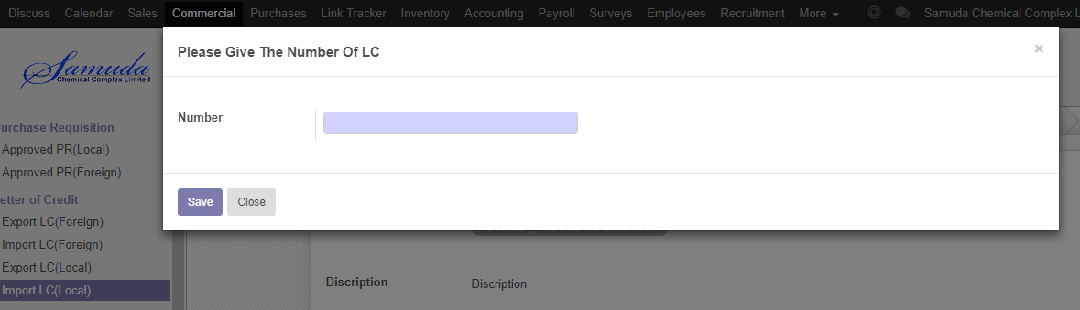

Figure: LC number window

## 2.3 Amendment creation by Commercial User/Manager

Amendment will be Confirm by Commercial user/Manager click **Amendment** button.

Amendment should be multiple and after save it will load to amendment tab.

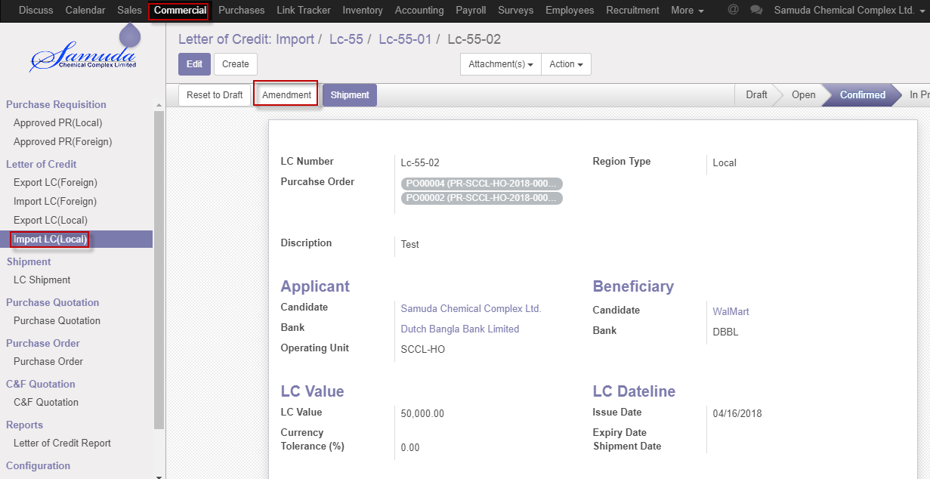

Figure: Amendment creation

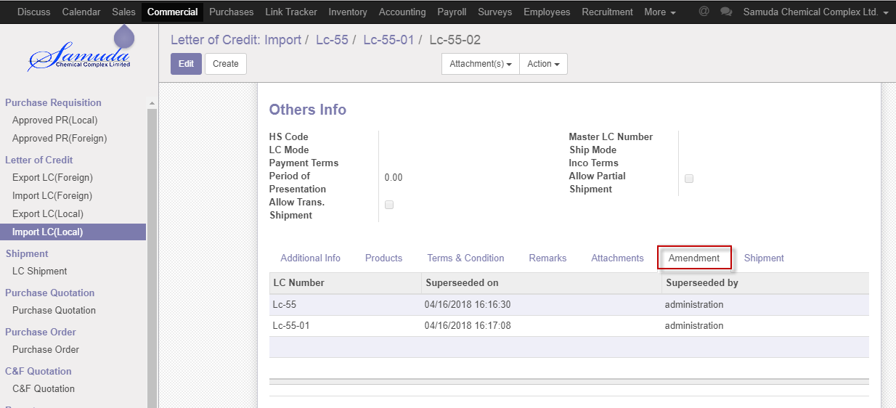

Figure: Amendment tab

## 2.4 Create Shipment by Commercial User/Manager

Shipment will be Confirm by Commercial user/Manager click **Shipment** button

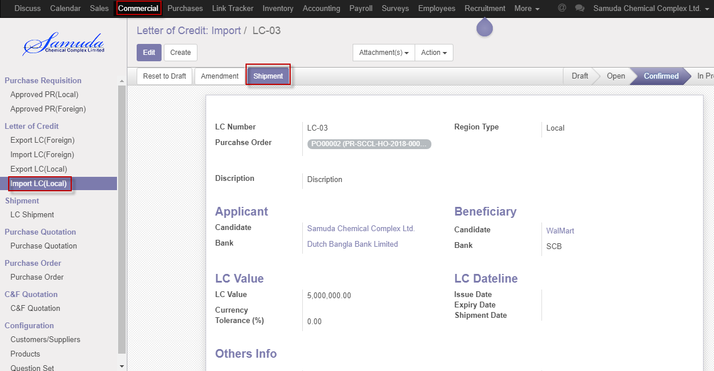

Figure: Create shipment

## 2.5 Shipment Cancel by Commercial User/Manager

Shipment will be canceled by Commercial user/Manager click **Cancel** button

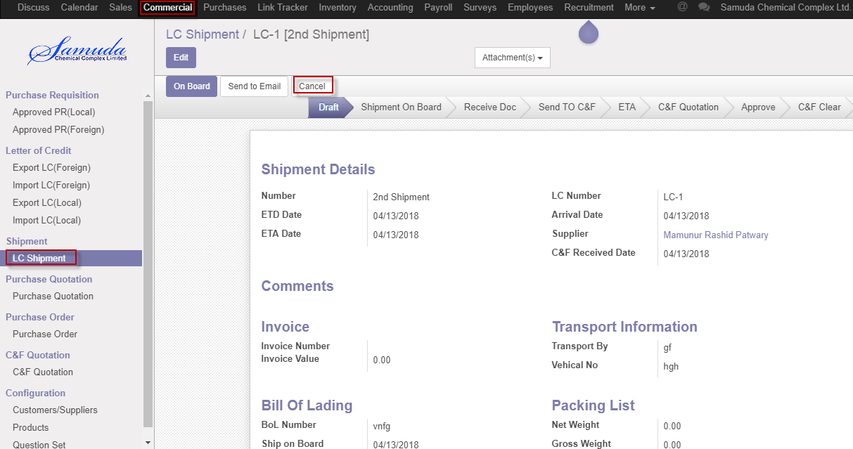

Figure: Cancel Shipment

## 2.6 Create On board by Commercial User/Manager

On board will be Confirm by Commercial user/Manger click **On board** button

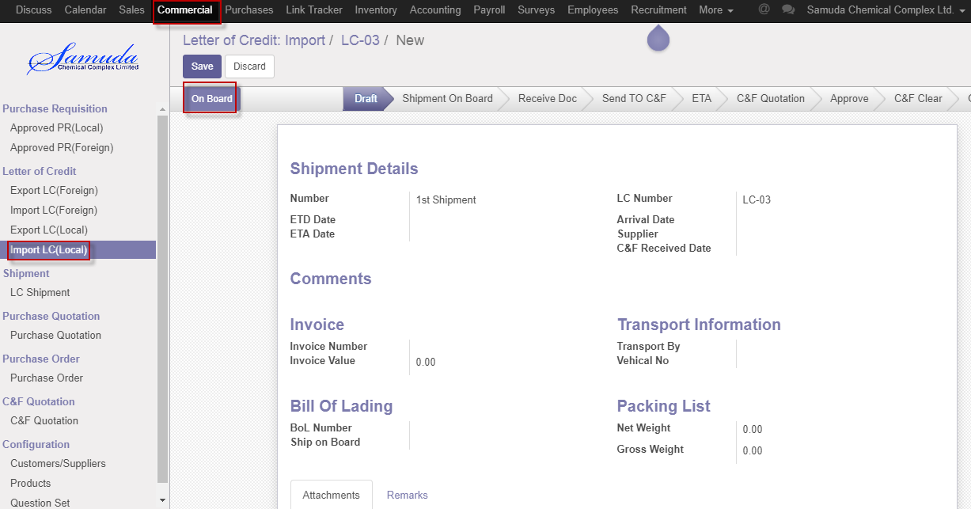

Figure: Create On board

After click On board button below window will open & will enter ETD date then **Save**

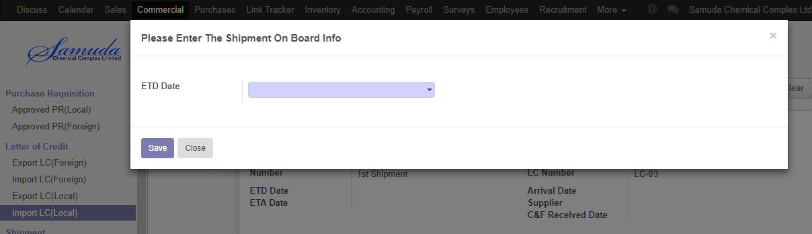

Figure: ETD date window

## 2.7 Create Receive doc by Commercial user/Manager

Receive doc will be created by Commercial user/Manager click **Receive doc** button

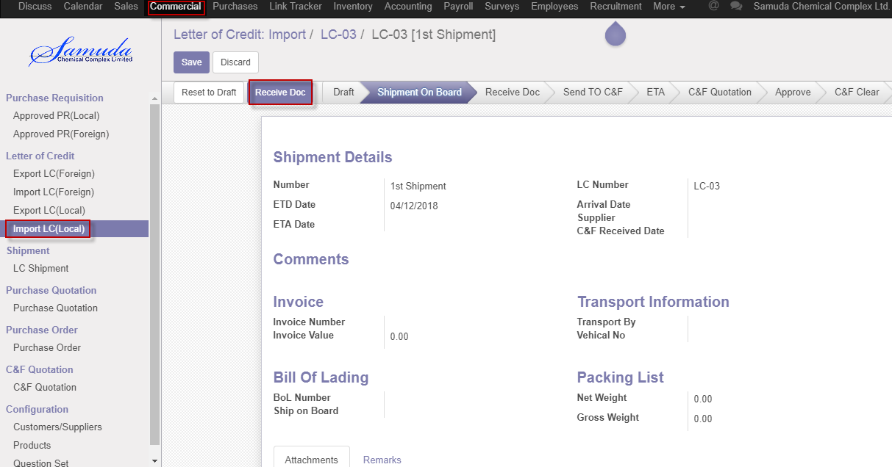

Figure: Create Receive doc

After click Receive doc button below window will open 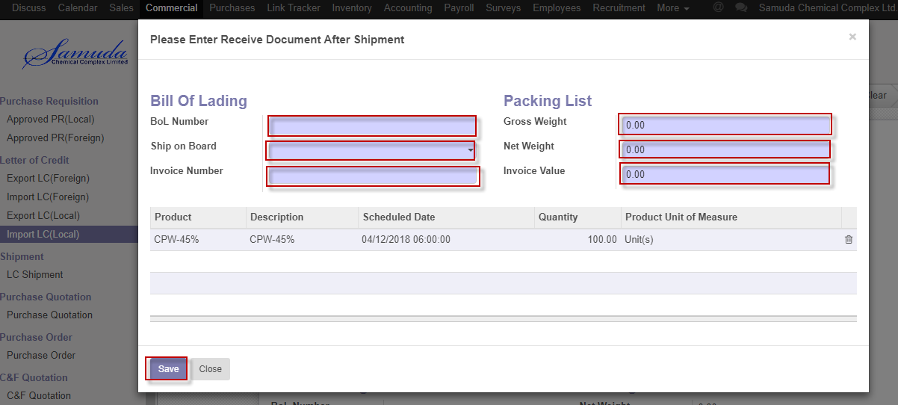

Figure: Receive doc after window

We need to set the following:-

**BoL number**: Enter BoL number.

**Ship on board**: Select ship on board.

**Invoice number**: Enter invoice number.

**Gross weight**: Enter gross weight.

**Net weight:** Enter net weight.

**Invoice value**: Enter invoice value.

**Product**: Commercial user/Manager can edit product Quantity if he wants.

After entering all information click **Save**.

## 2.8 Confirm Send To C&F by Commercial User/Manager

Send TO C&F will be created by Commercial User/Manager click **Send To C&F** button

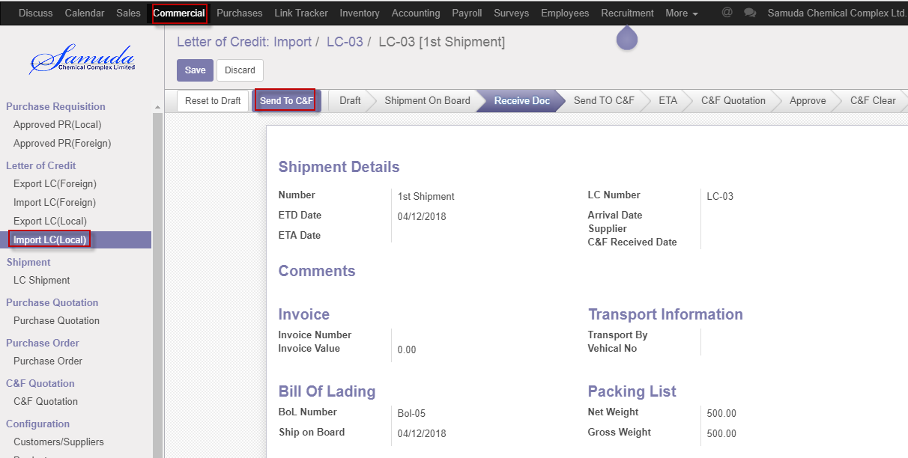

Figure: Confirm Send To C&F

After click Send To C&F button below window will open 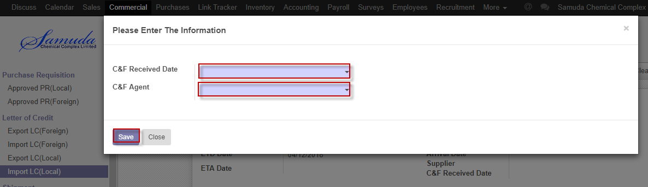

Figure: Send To C&F after window

We need to set the following:-

**C&F Received date**: Select C&F received date.

**C&F agent**: Select C&F agent

After entering all information click **Save**.

## 2.9 Confirm ETA by Commercial user/Manager

Send TO C&F will be created by Commercial user/Manager click **Send To C&F** button

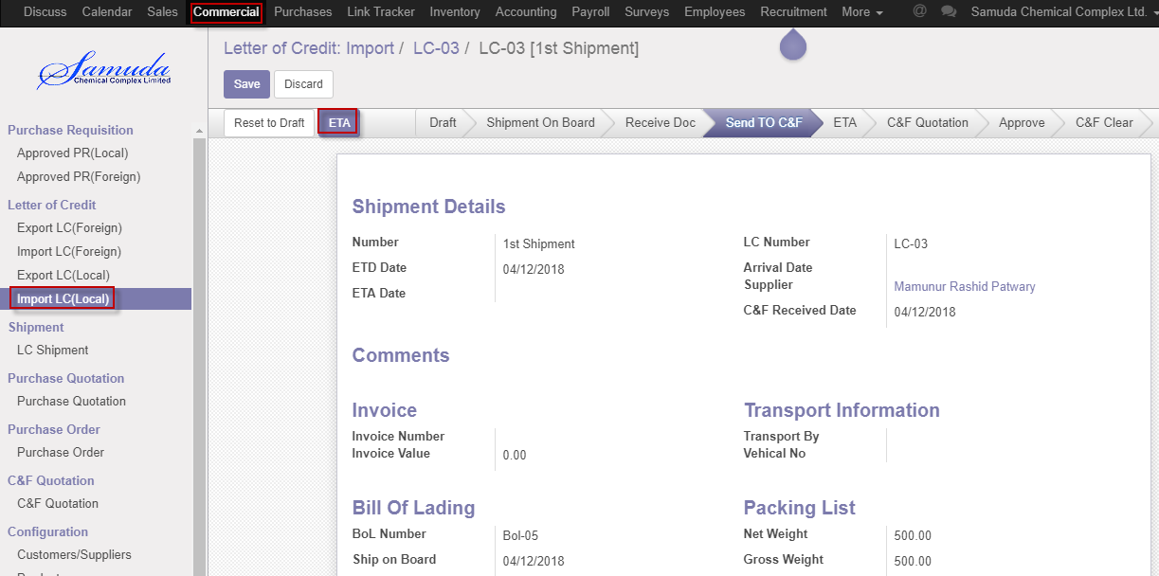

Figure: Confirm ETA

After click ETA button below window will open 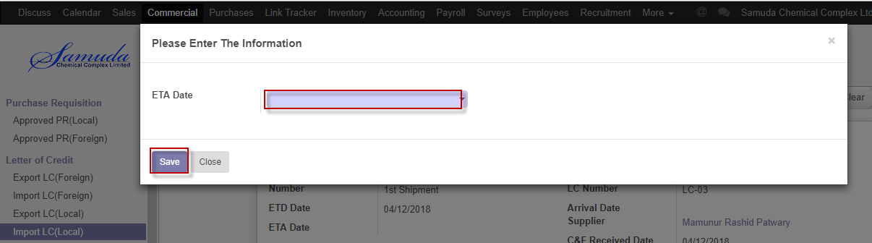

Figure: ETA after window

We need to set the following:-

**ETA date**: Select ETA date.

After entering all information click **Save**

## 2.10 Confirm C&F quotation by Commercial user/Manager

C&F quotation will be created by Commercial user/Manager by click **C&F quotation** button

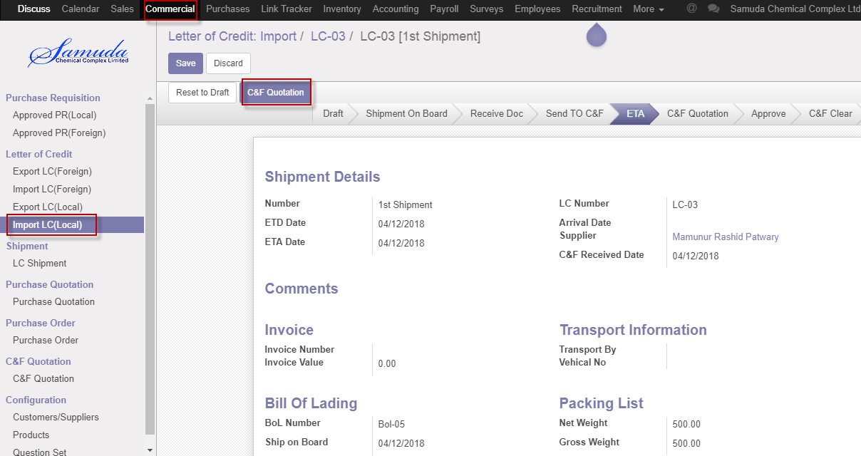

Figure: Confirm C&F quotation

After click C&F quotation button below window will open then confirm order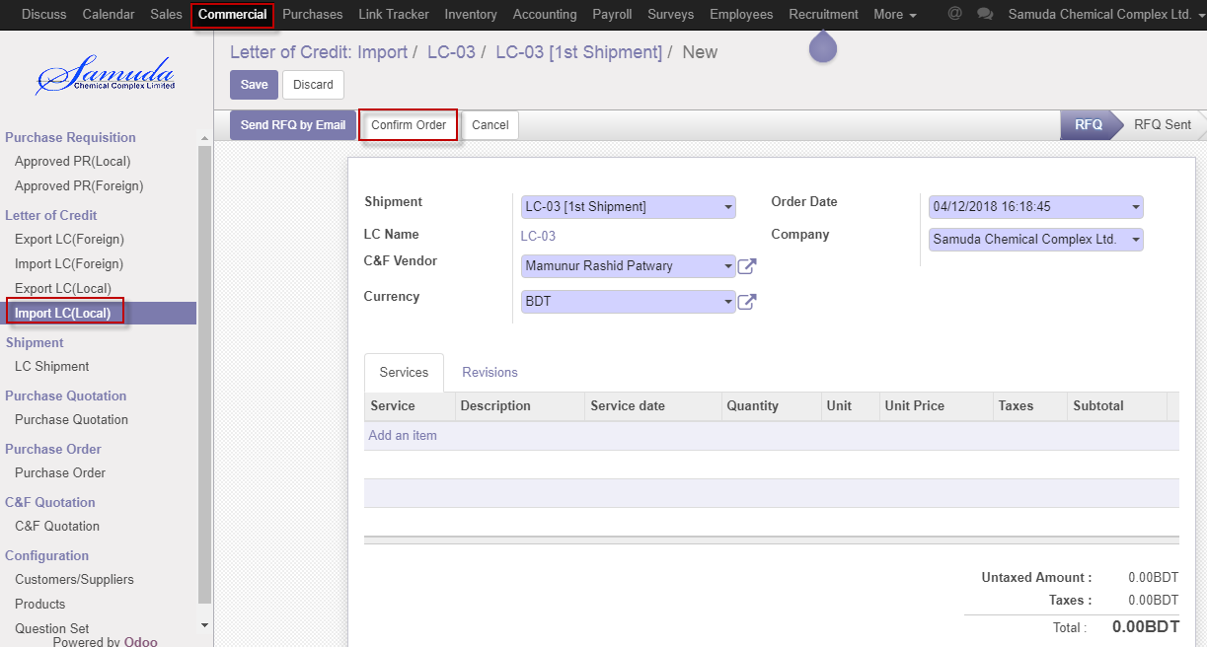

Figure: Confirm order

## 2.11 Confirm C&F clear by Commercial Manager

C&F clear will be created by Commercial Manager click **C&F** button

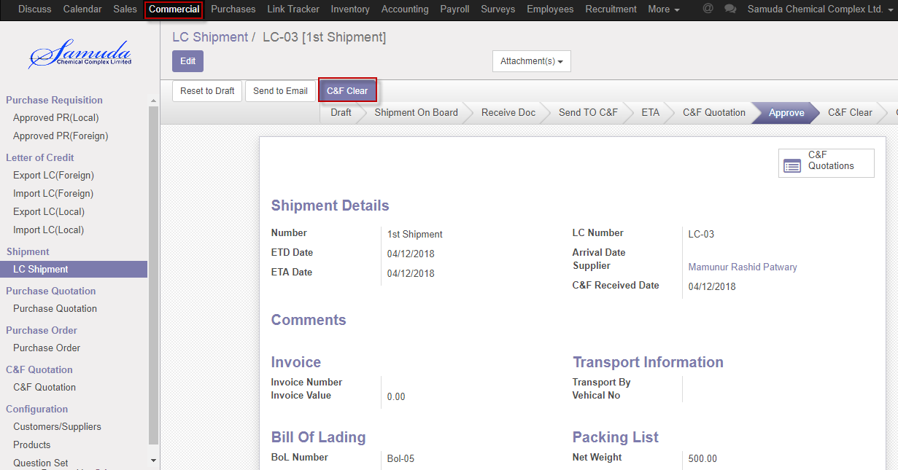

Figure: Confirm C&F clear

After click C&F clear button below window will open 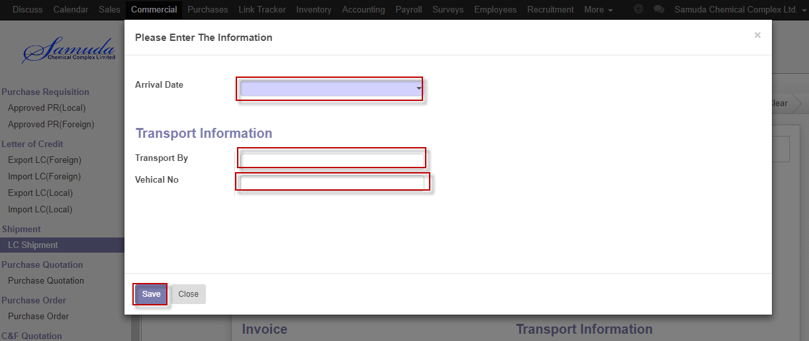

Figure: C&F clear after window

We need to set the following:-

**Arrival date**: Select arrival date.

**Transferred By**: Enter transferred by

**Vehicle No**: Enter vehicle no

After entering all information click **Save**

## 2.12 Shipment done by Commercial Manager

Shipment done state will come after Gate in completed .Commercial Manager shipment will done by click **Done** button

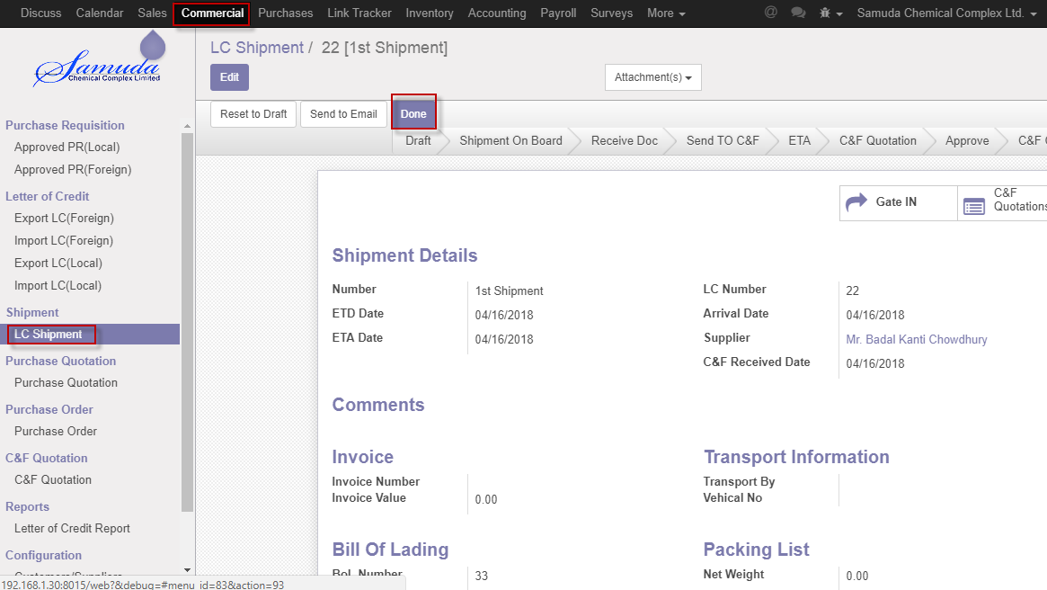

Figure: Done state

After Done Comments window will open then click **save** button then shipment will go done state.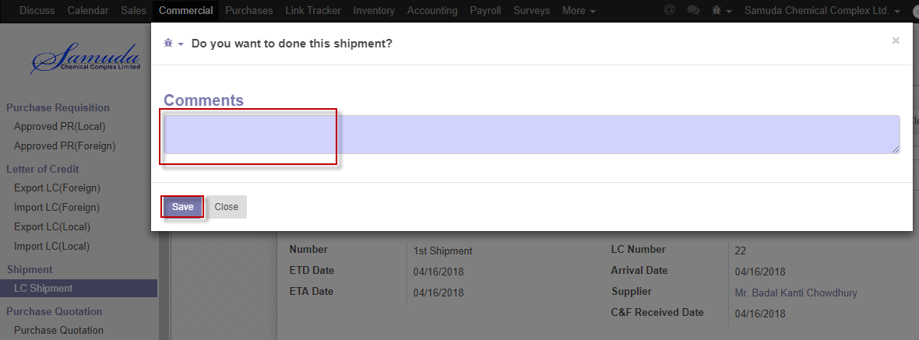

Figure: Comments window

## 2.13 LC Evaluation by Commercial Manager

Doing the LC creation when All Shipment will done state then LC evaluation form will appear then Commercial Manager will mark then click **save** button. Then LC will go done state.

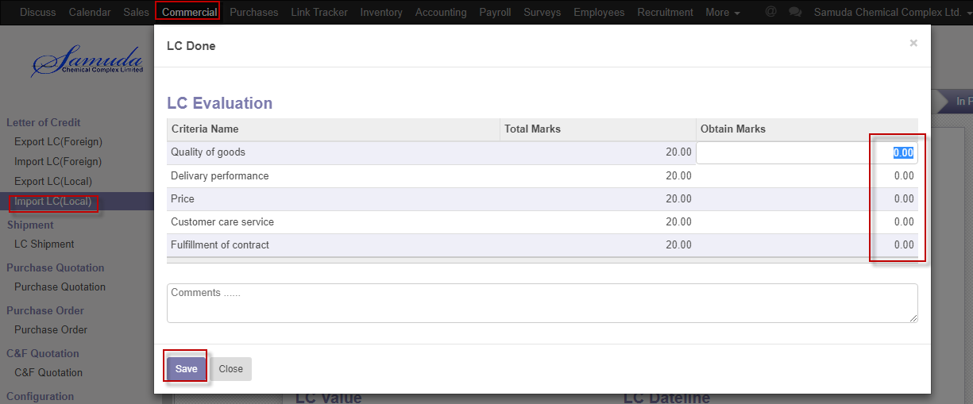

Figure: LC Evaluation

## 2.14 LC done by Commercial Manager

LC done state will complete when LC against all shipment will done .Commercial Manager LC will done by click **done** button .

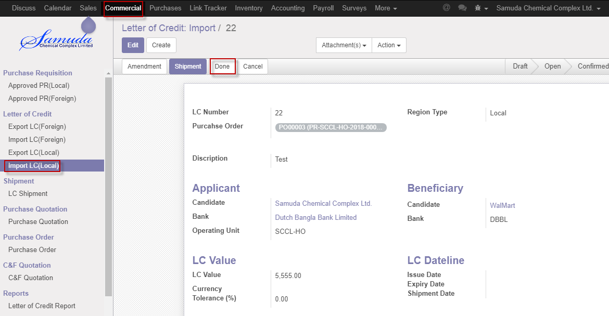

Figure: LC done

## 2.15 Send RFQ Email by Commercial Manager

Commercial Manager is capable to Send RFQ Emil to authority if he wants. Send RFQ Email by **Send RFQ by Email** button.

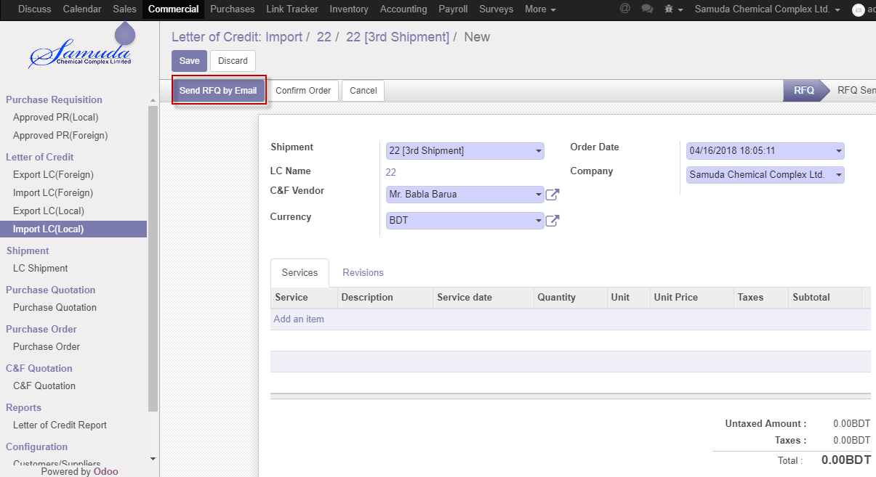

Figure: Send RFQ by email

After Click Send RFQ by Email following window will open then click **save** button 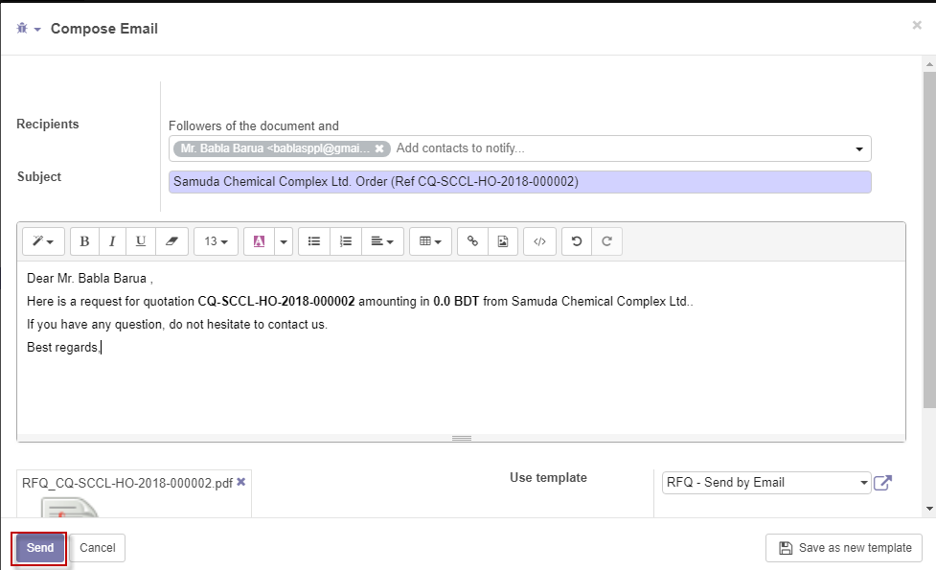

Figure: Email window

# 3. Reports

## 3.1 Letter of Credit reports view by Commercial Manager

To see the Letter of credit reports use the menu **Commercial ‣Reports>** **Letter of Credit report>Select status>>Print**

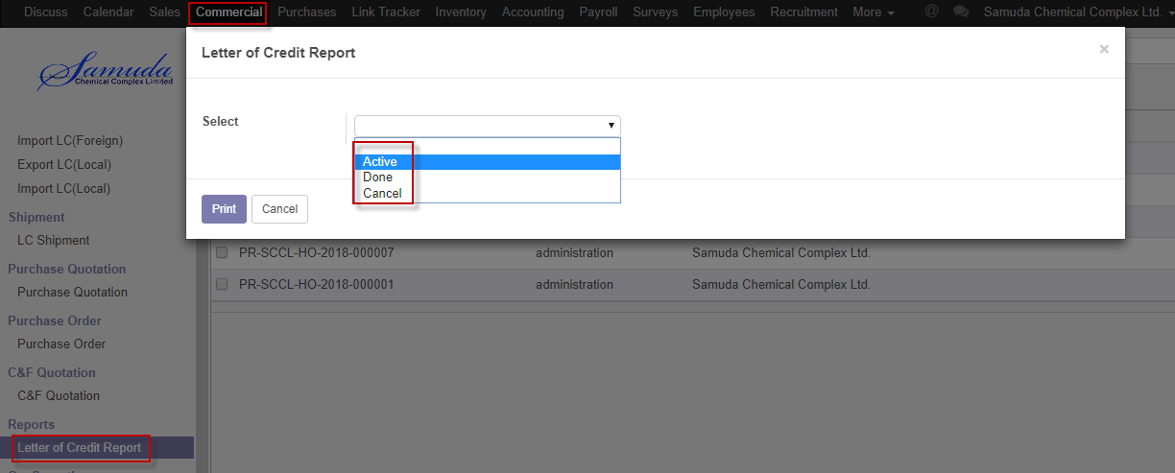

Figure: Letter of Credit report print view

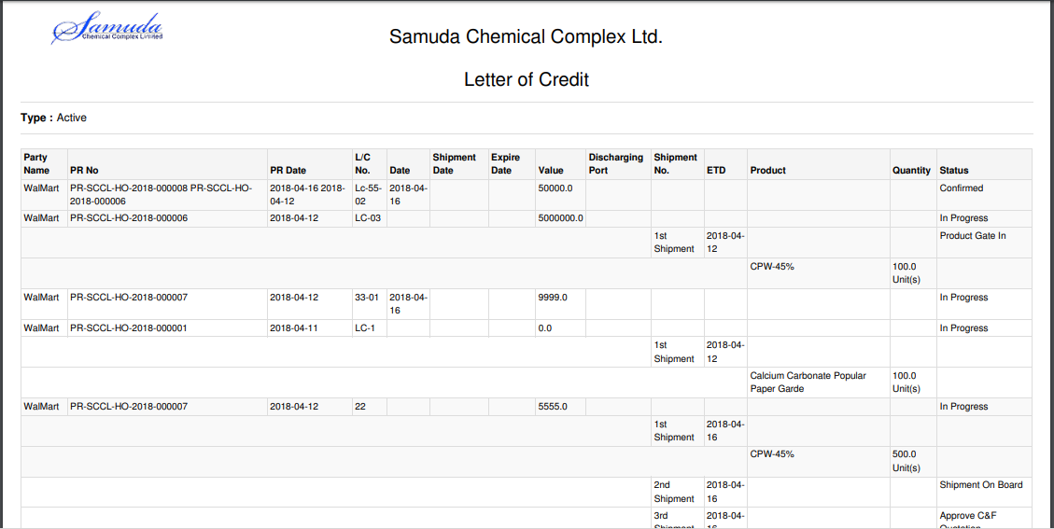

Figure: Letter of credit reports PDF format